VDS2425 Project Report

Metadata
- Version: 1.0
- Students: Amudhaanandheswaran Selvaraj (2468517), Apu Chandra Bhowmick (2469640), Nuthi Raviteja Pediredla (2468496)
- Group number: group-13
- Dataset: Football

Project description
We analysed European football data from 2008 to 2016) to help the club coach to strategize player acquisitions and tactical improvements. We focused on finding young players to sign, evaluating team performance trends, and assessing key match statistics like possession. The goal is to provide actionable insights through visualizations.
Key Features in the Data
- Matches: Results, goals, cards, and possession stats.
- Players: Age, goals, assists, and FIFA ratings (mapped to team performance)
- Teams: League rankings, points over seasons, and match history.
- Match Events: Shots, corners, fouls, and how possession affects wins.

Design
We broke down the coach’s question into 3 tasks:

3.1 Operationalisation: from questions to tasks

TASK-1:

- Title: Finding Youngstars
- Question: Who are the top young players?
- Action: Ranked FIFA overall ratings/ Potential rating
- Target: Player attributes
- Objects: Player, Overall rating
- Measure: Age, Potential, Overall Rating
- Groupings: Age, Position

TASK-2:

- Title: High Impact Players
- Question: Who contributes most to goals and assists?
- Action: Analyze overall Goals, Assists,
- Target: Player attributes
- Objects: Player, Match_Goals
- Measure: Goals, Assists
- Groupings: Player, PositionReference
TASK-3:

- Title: Excluding Booked Players
- Question: Who should we scout (excluding our team’s players)?
- Action: Filter
- Target: Match/Team ID
- Objects: Player
- Measure: Team, Team Attributes
- Groupings: League

TASK-4:

- Title: Tracking Team Progress
- Question: Which teams have improved the most in recent years?
- Action: Compared points per season and trends
- Target: Team Attributes
- Objects: Team, Match
- Measure: Points, Goals difference
- Groupings: Season, League
TASK- 5:

- Title: Team Trend Over Sessions
- Question: How has our team progressed over the years?
- Action: Tracked league points per season and compared trends
- Target: Team Attributes
- Objects: Team, Match
- Measure: Wins, Points, Goals Scored
- Groupings: Season, home/away
TASK-6:

- Title: Opponent Analysis with our Team
- Question: Which teams has our team performed against the best and the worst over the years?
- Action: Group and compare
- Target: Match
- Objects: Team, Match
- Measure: Win/ Loss ratio
- Groupings: Opponent

3.2 The design process
DIVERGE PHASE
These graphs represent the overall and potential rating of the top players under age 23:
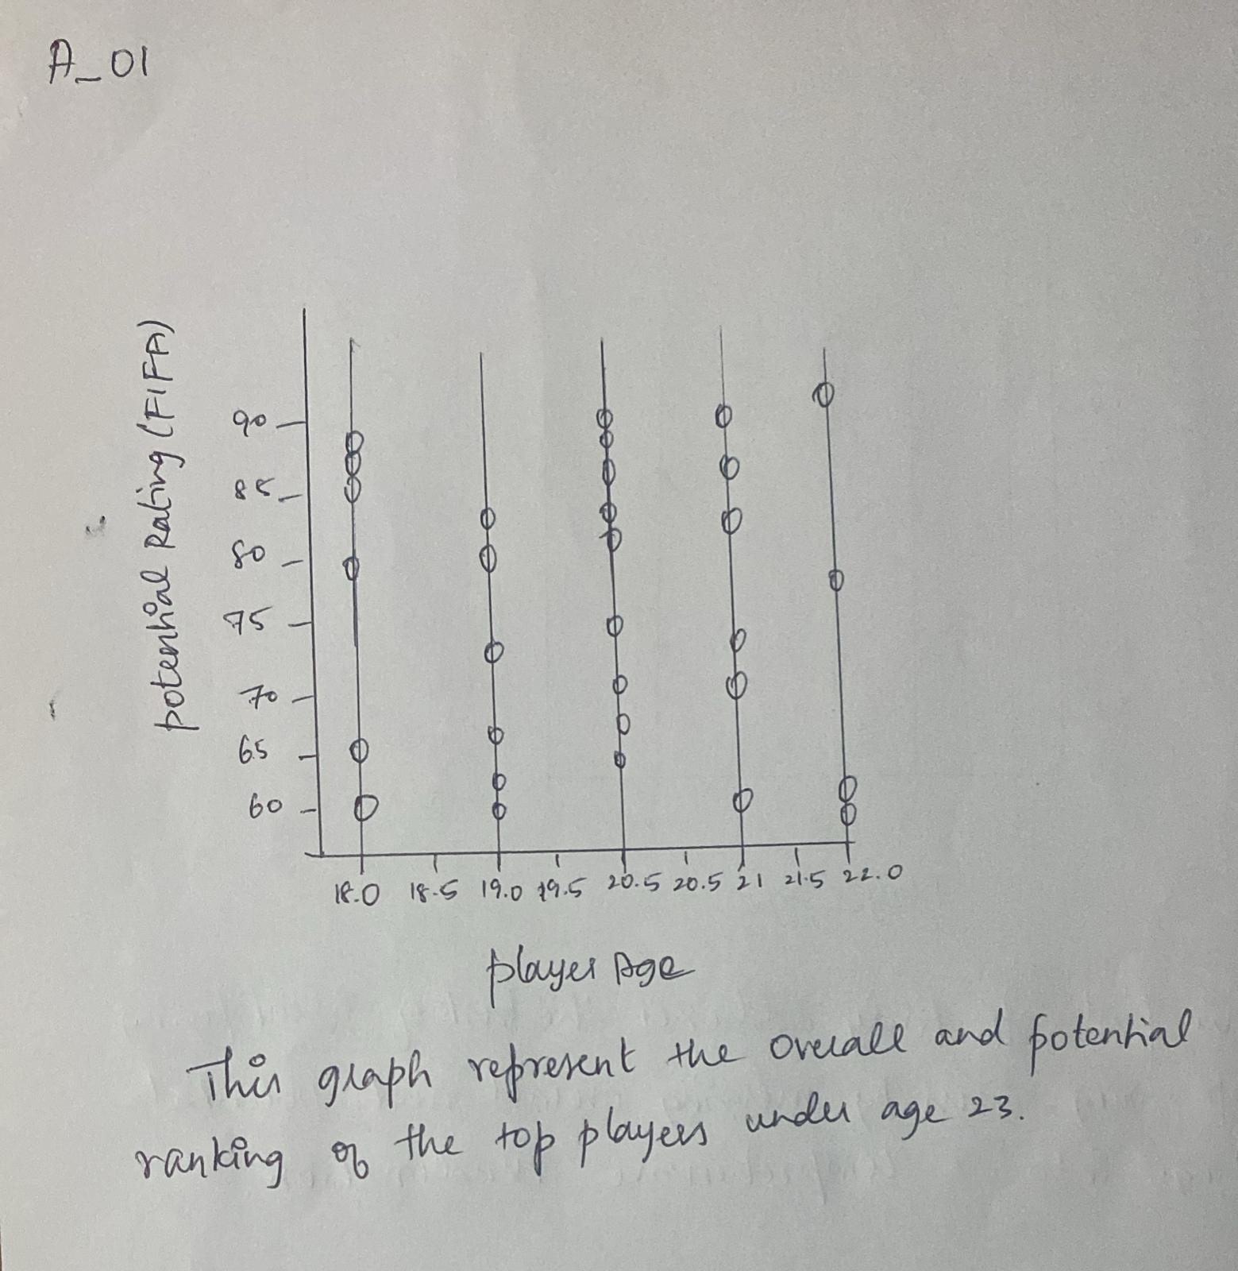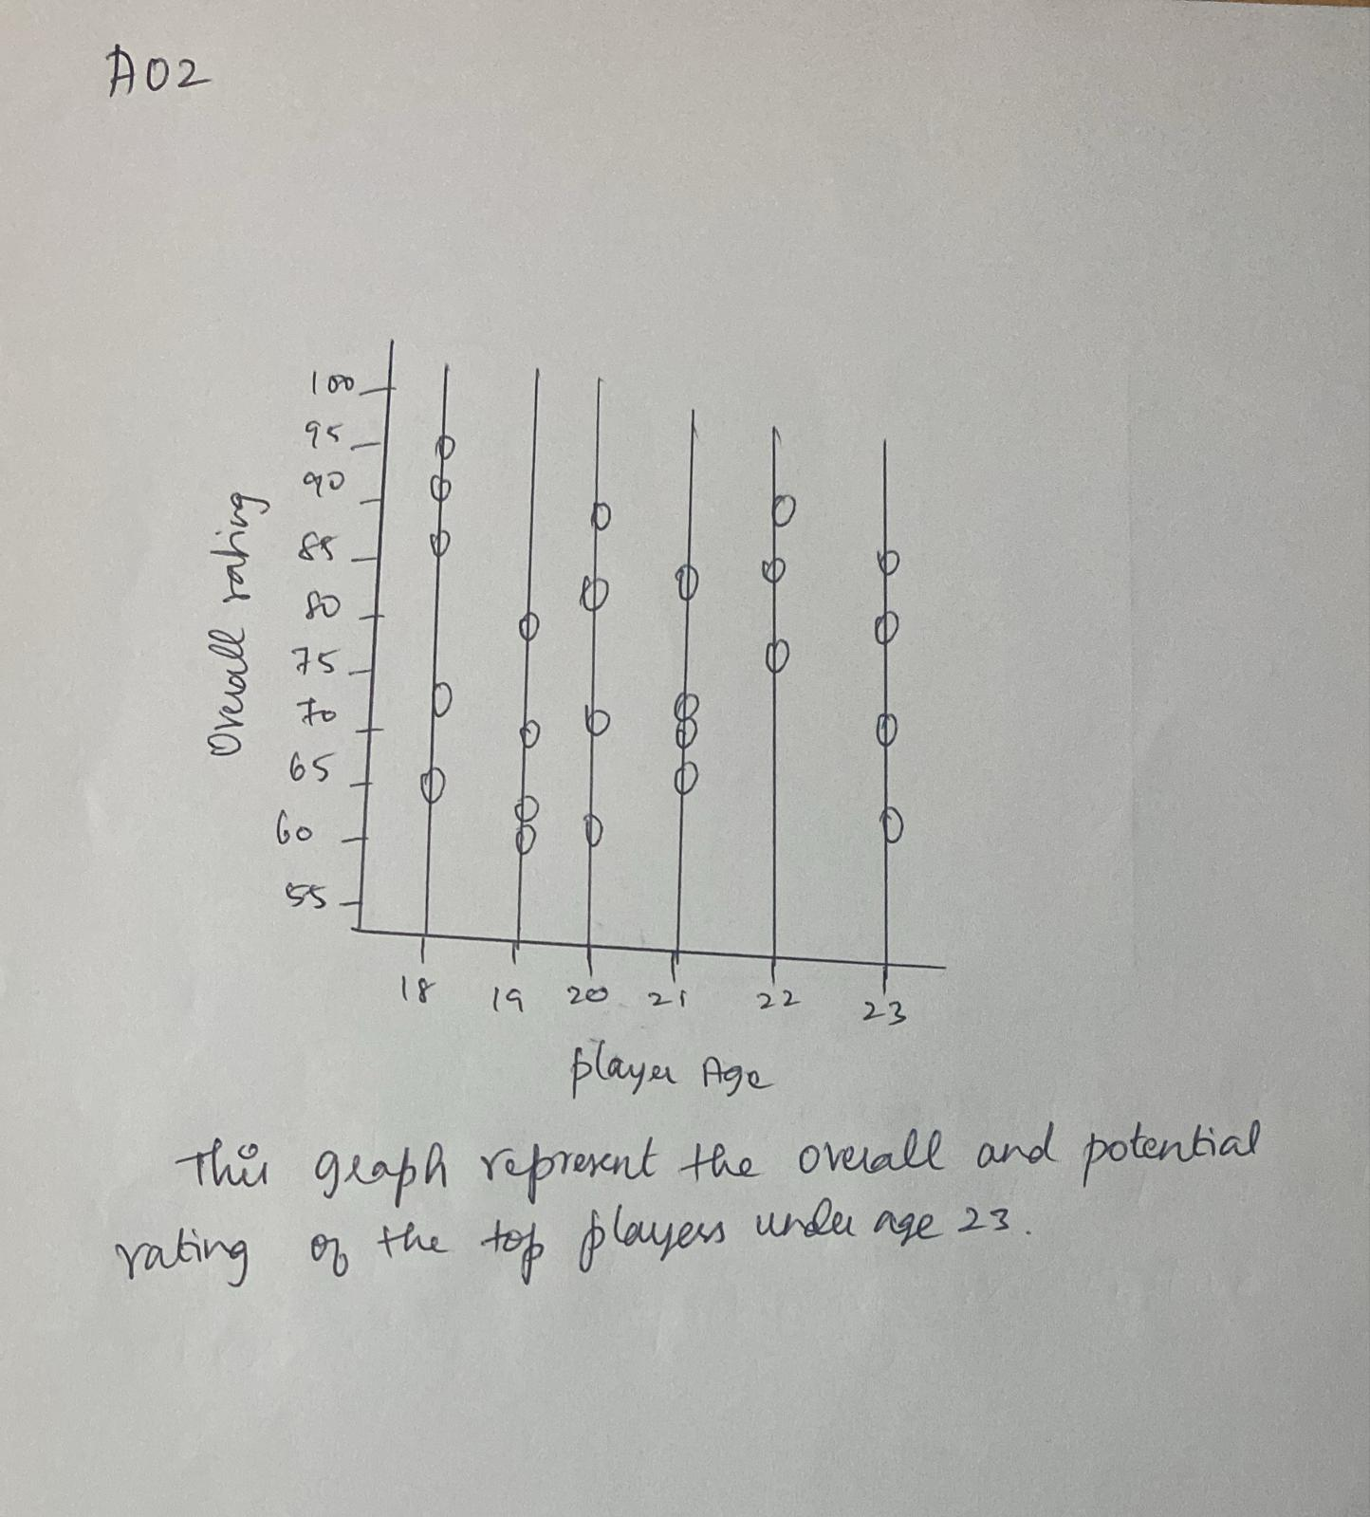
The graphs represent the top players of goals and assists
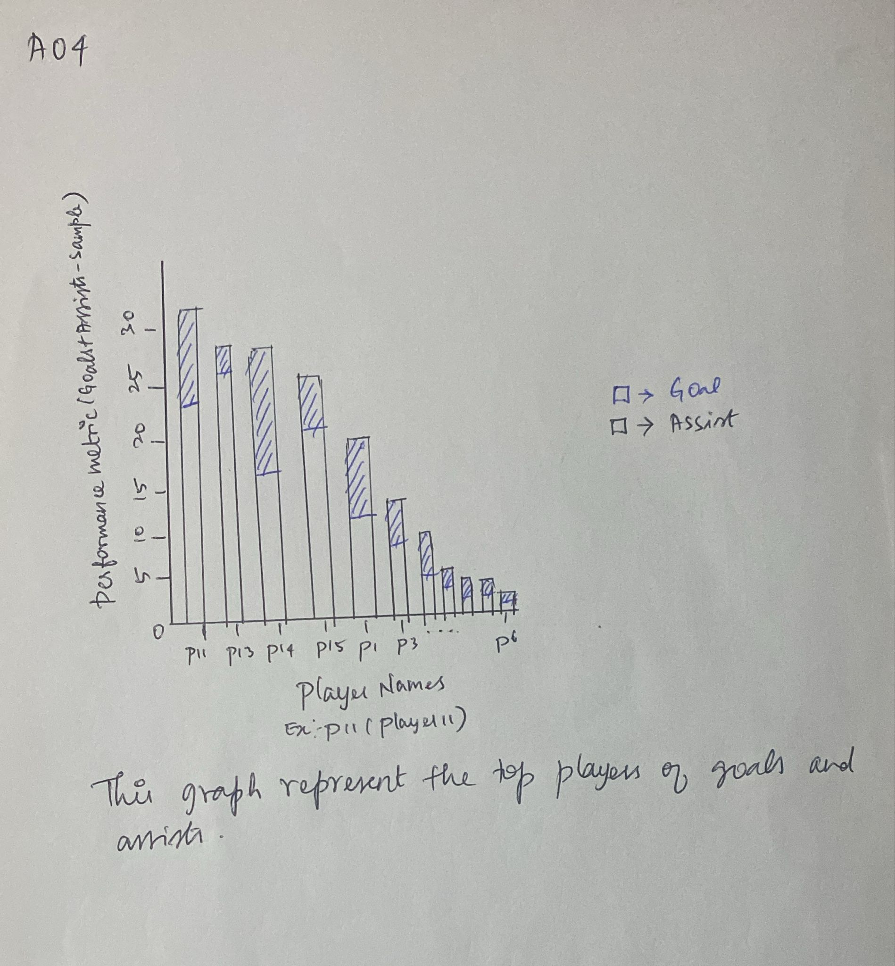
This graph represents excluding our previous team members and fixing the new players
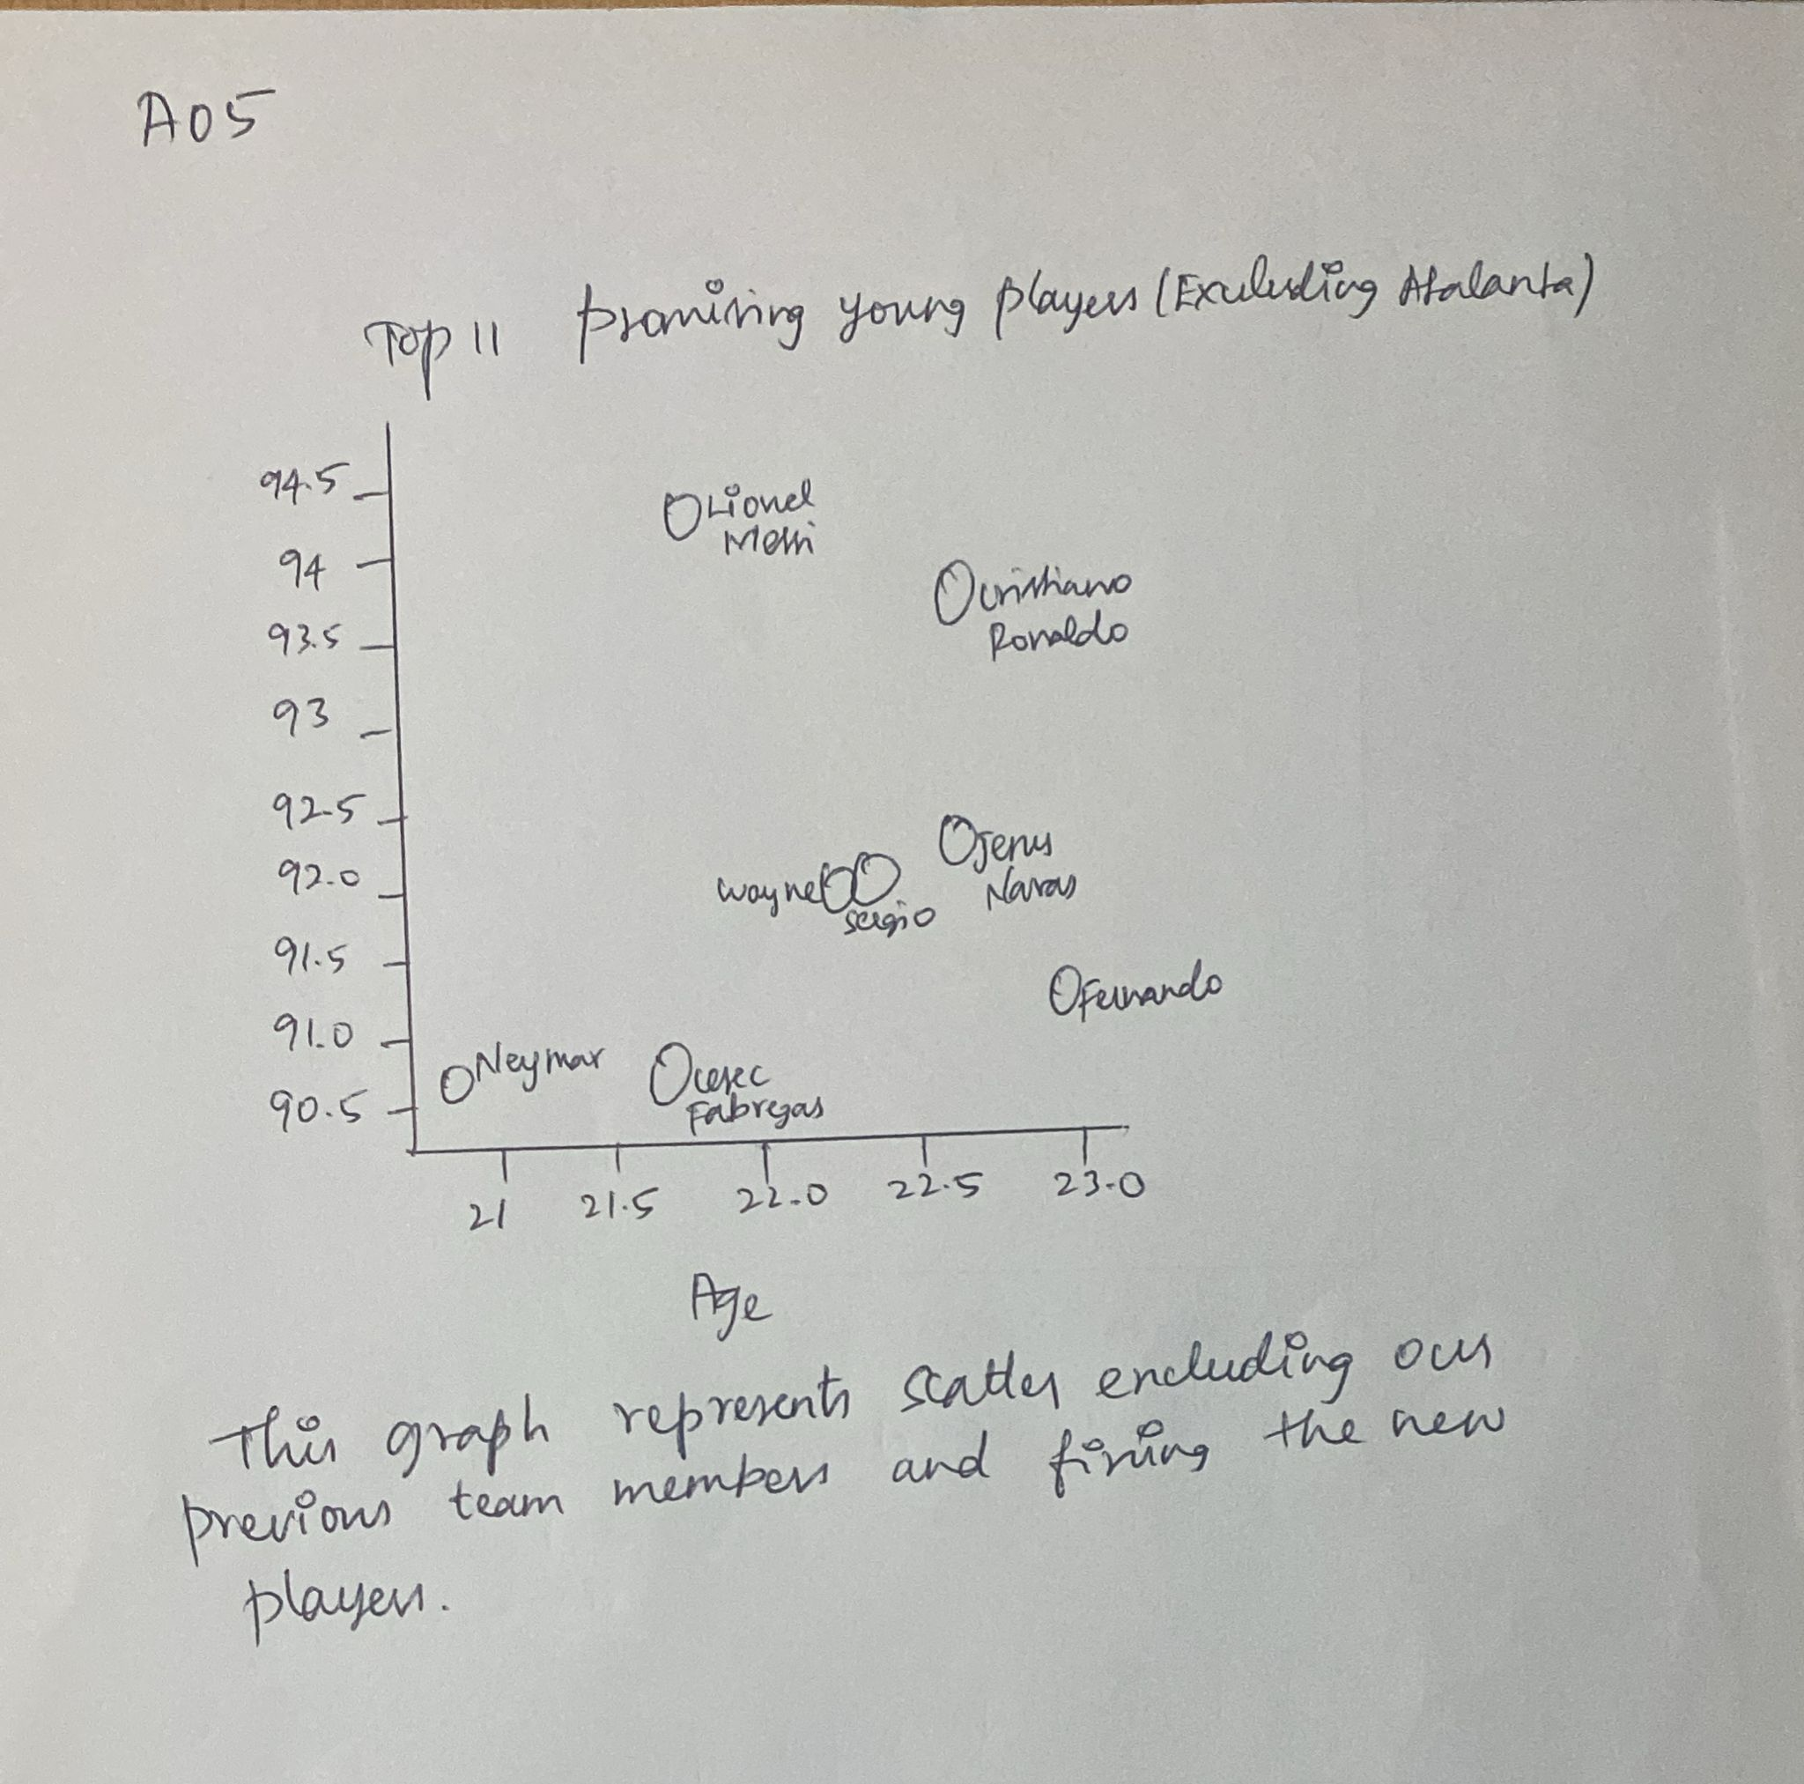
The graph represents the top-performing teams in last recent years
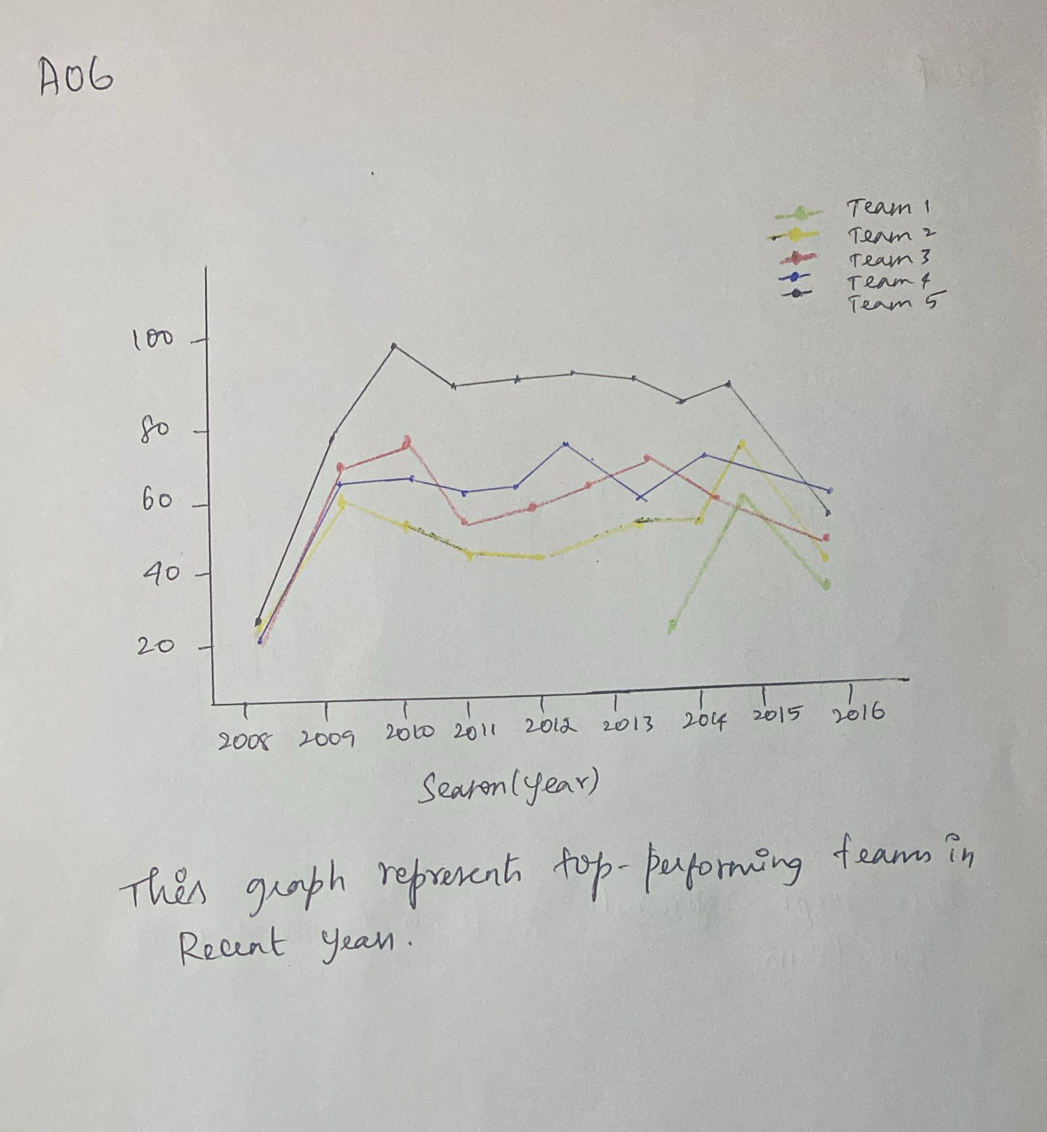
The graph represents how our team performed in all the leagues and seasons
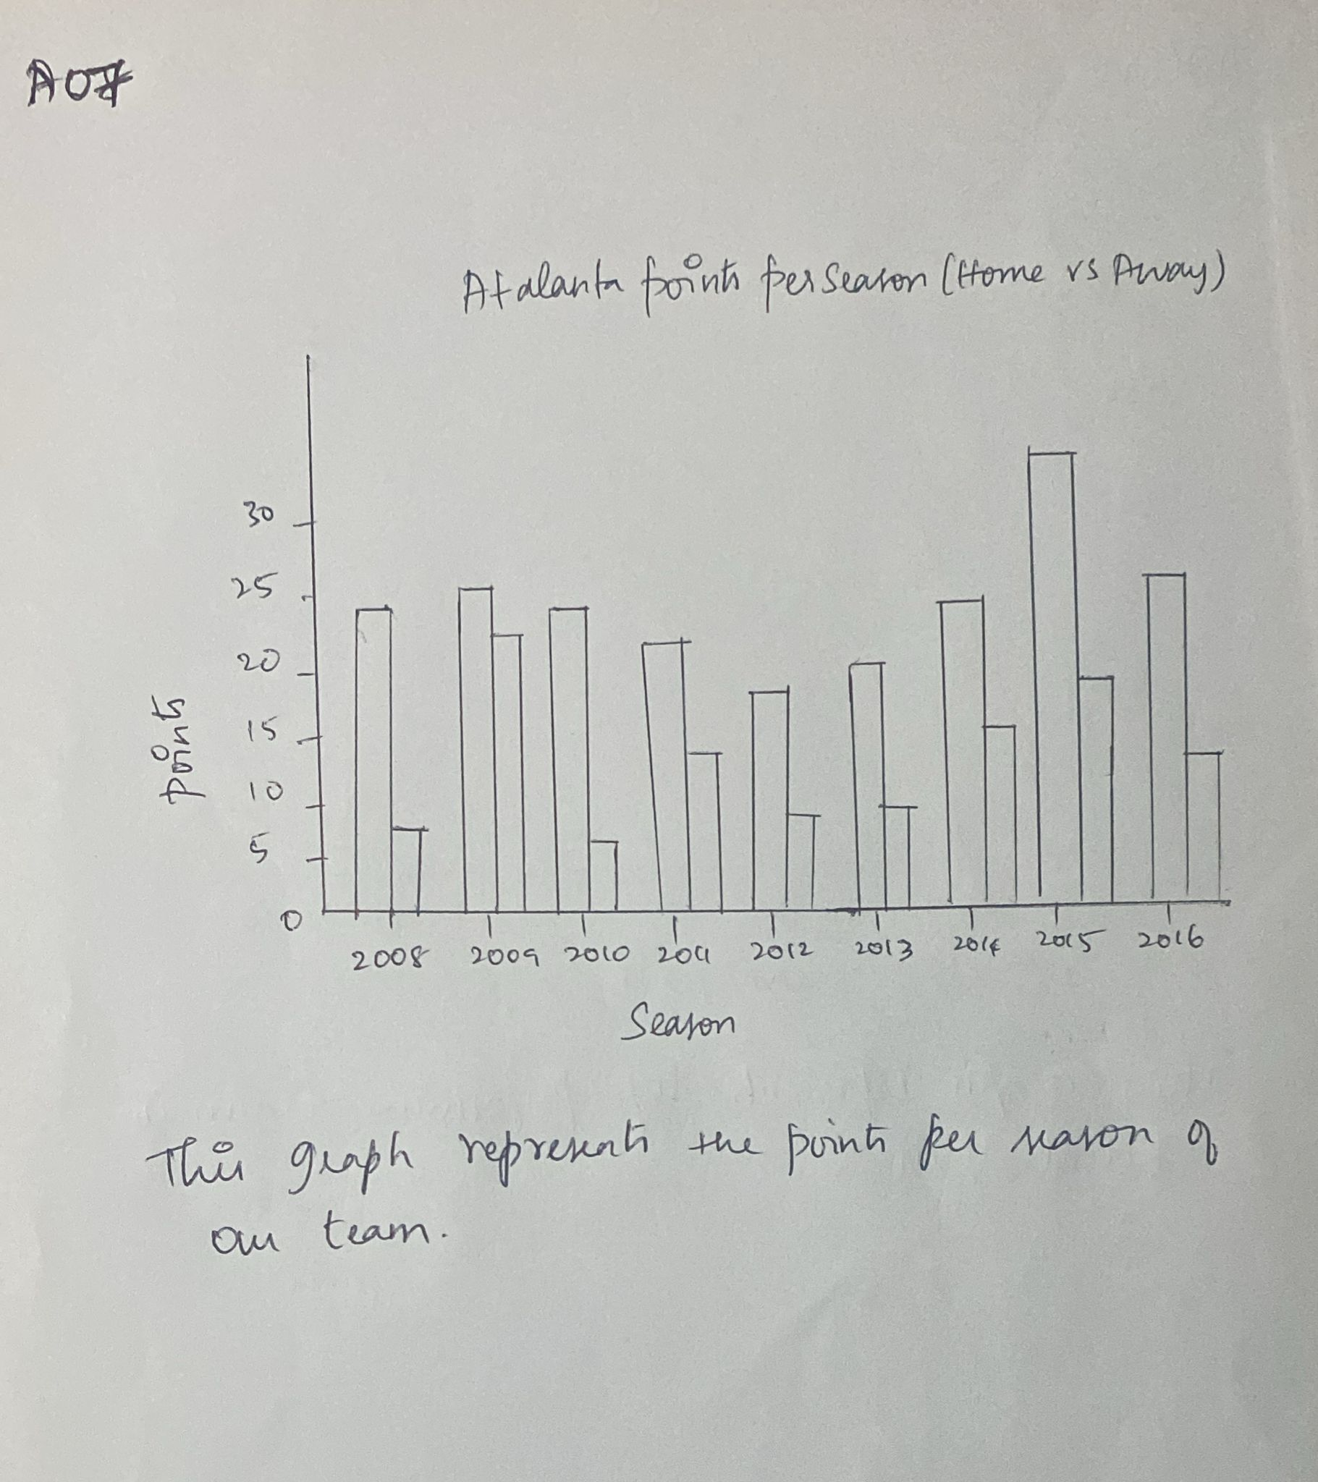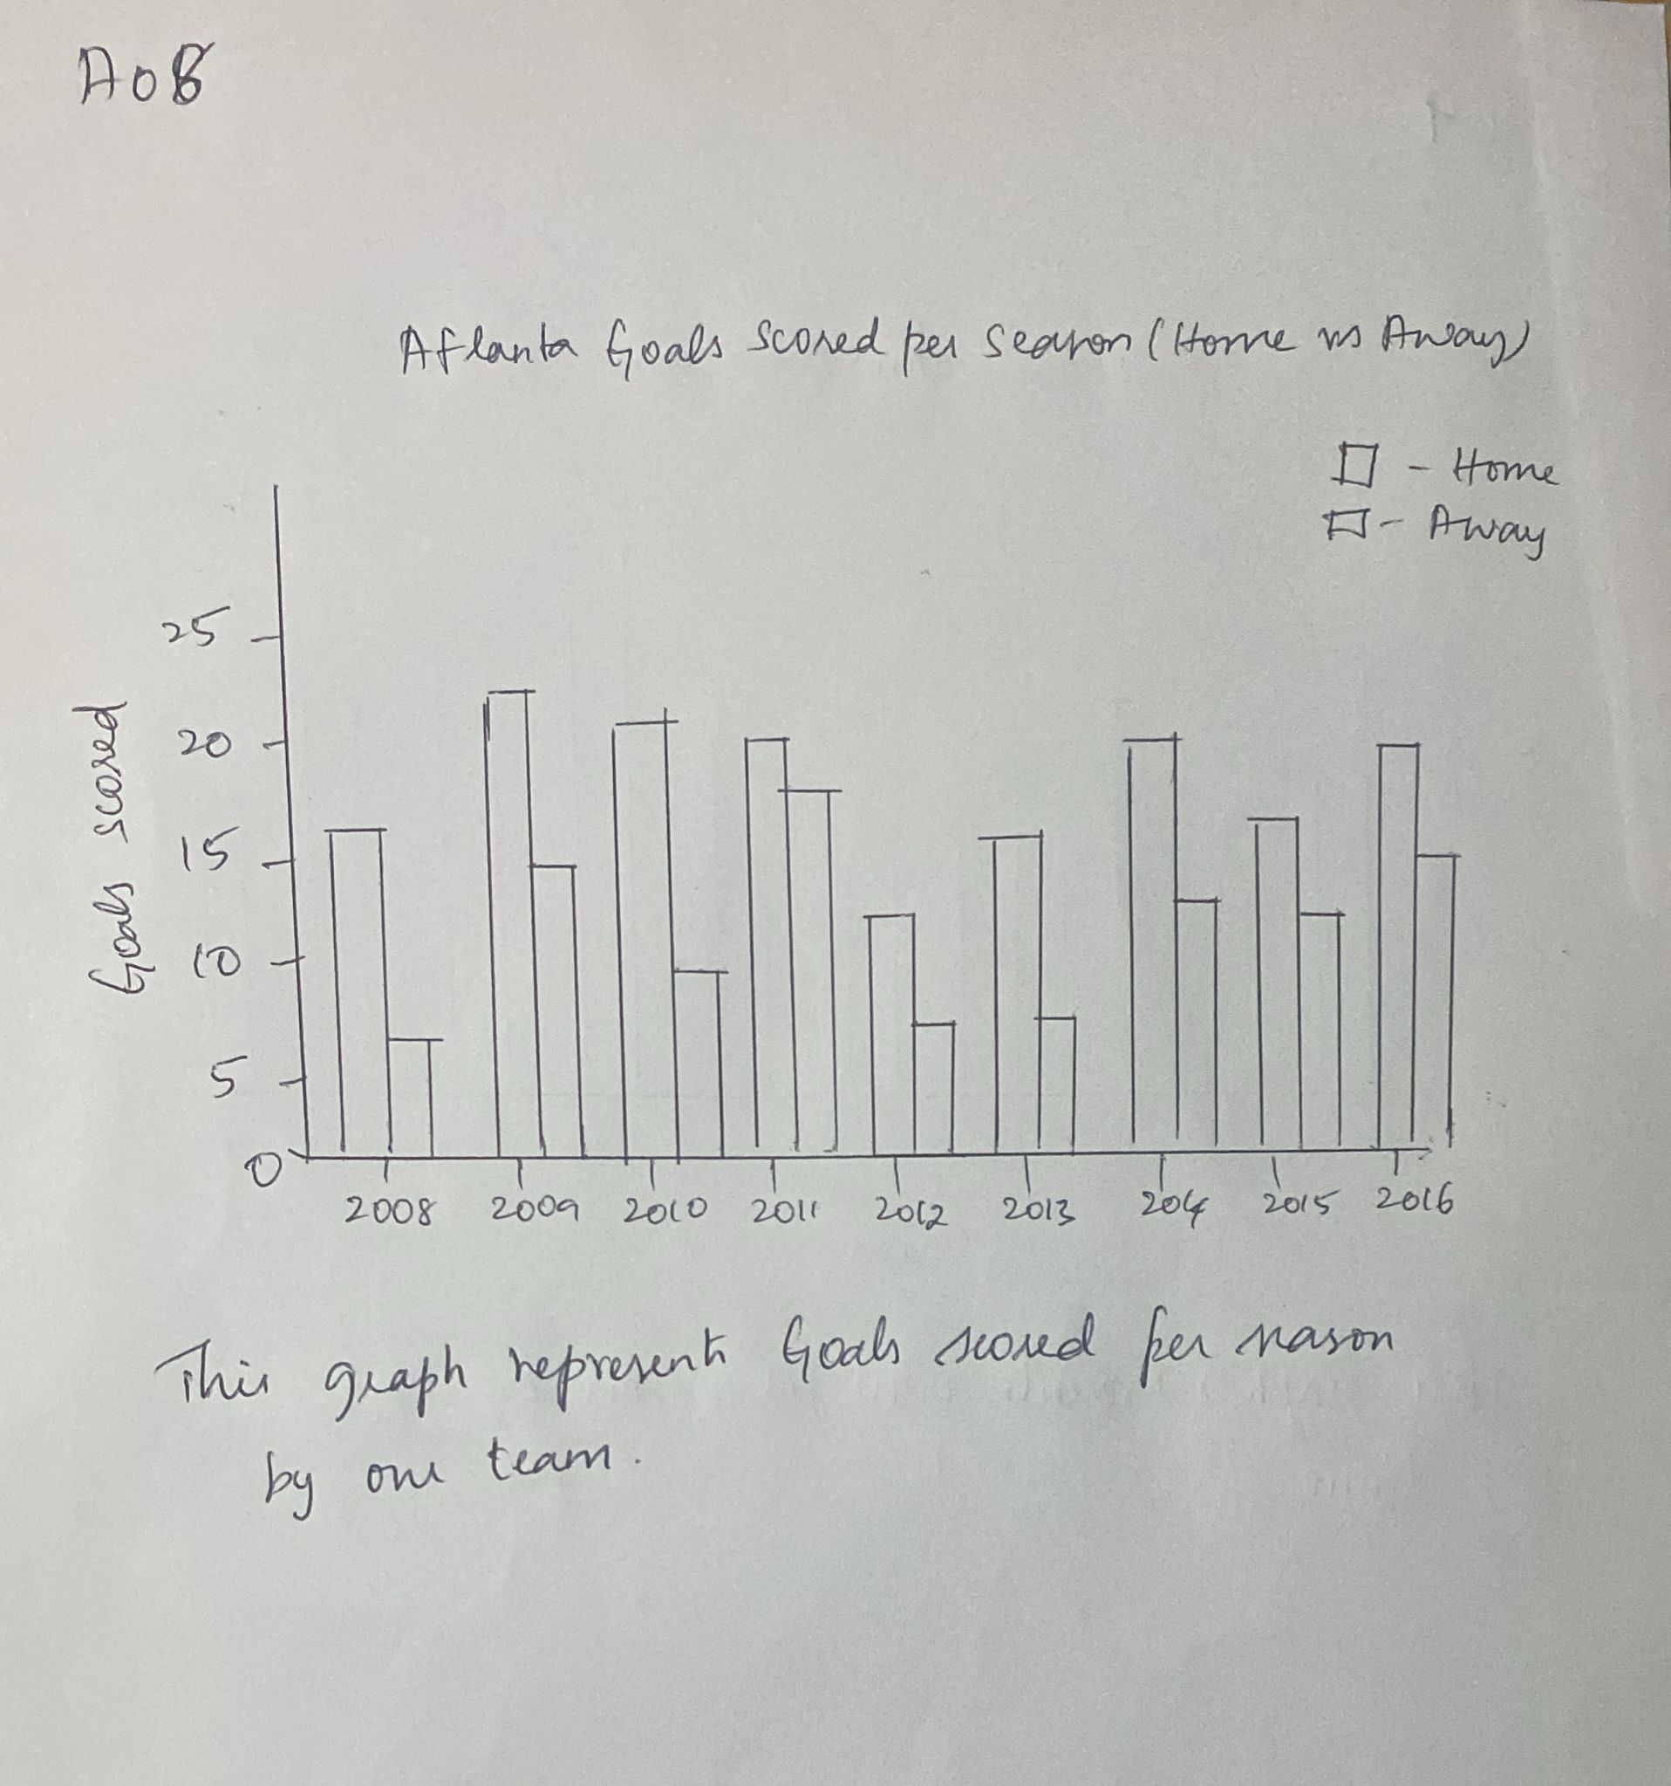

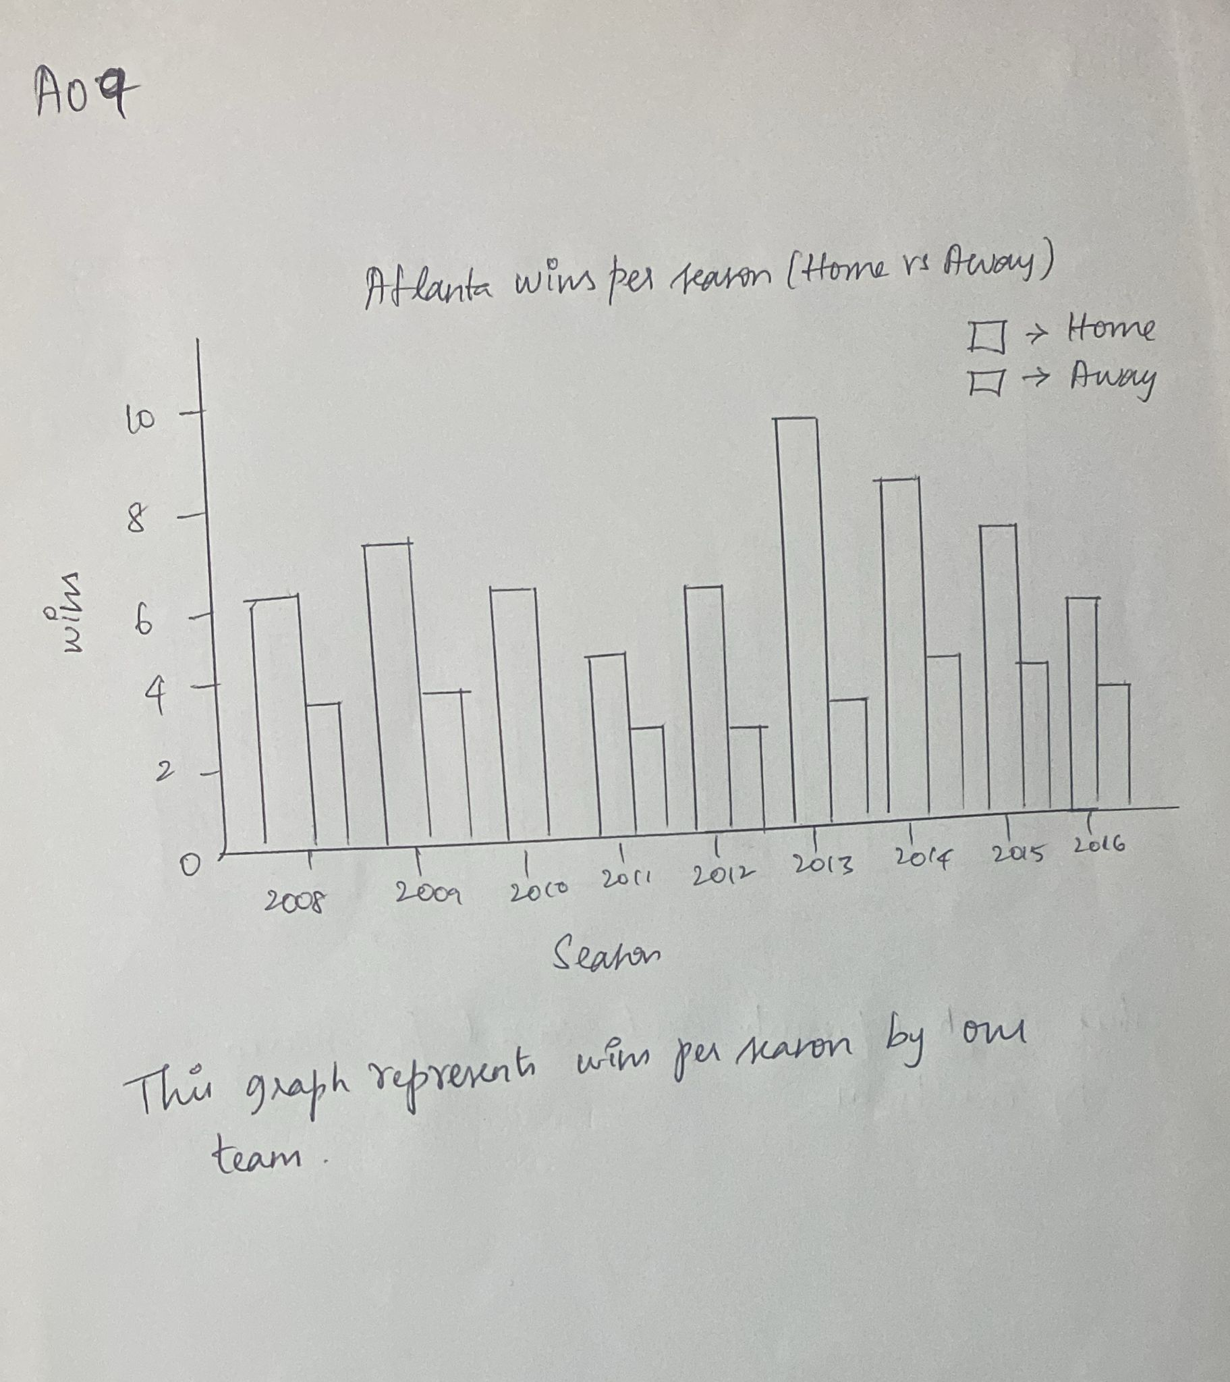
The graph represents how our team performed against the best and the worst over the years
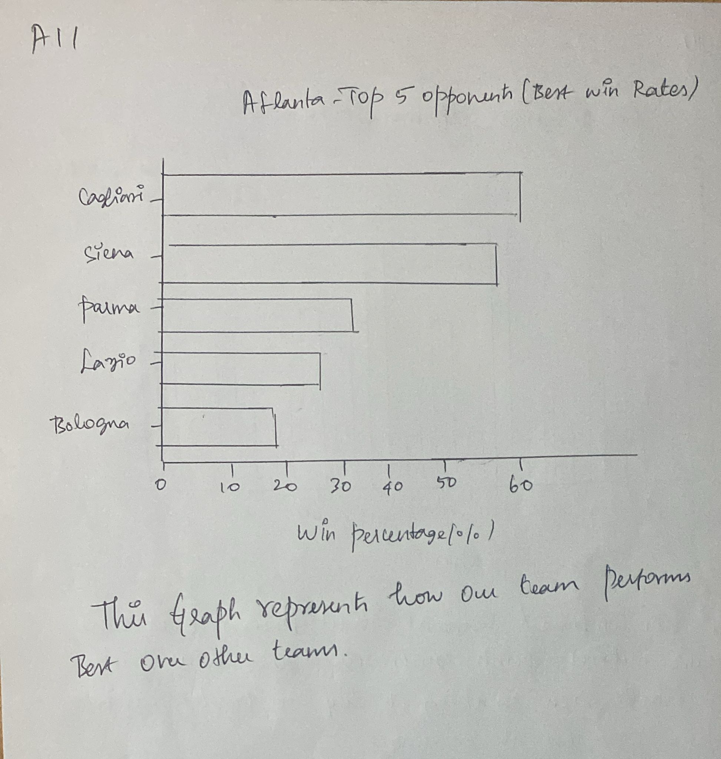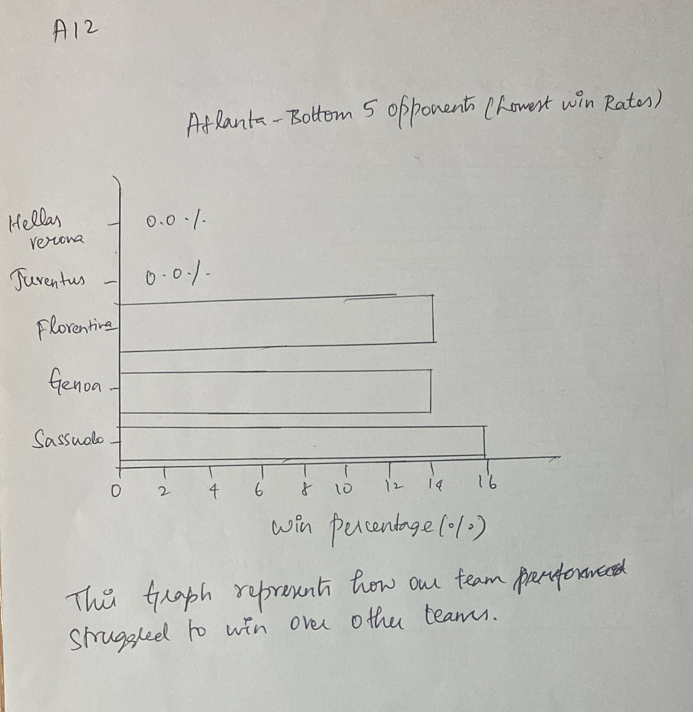

EMERGE PHASE:
For Task 1:
To make the graph clearer, I combined the graphs of potential and overall rating
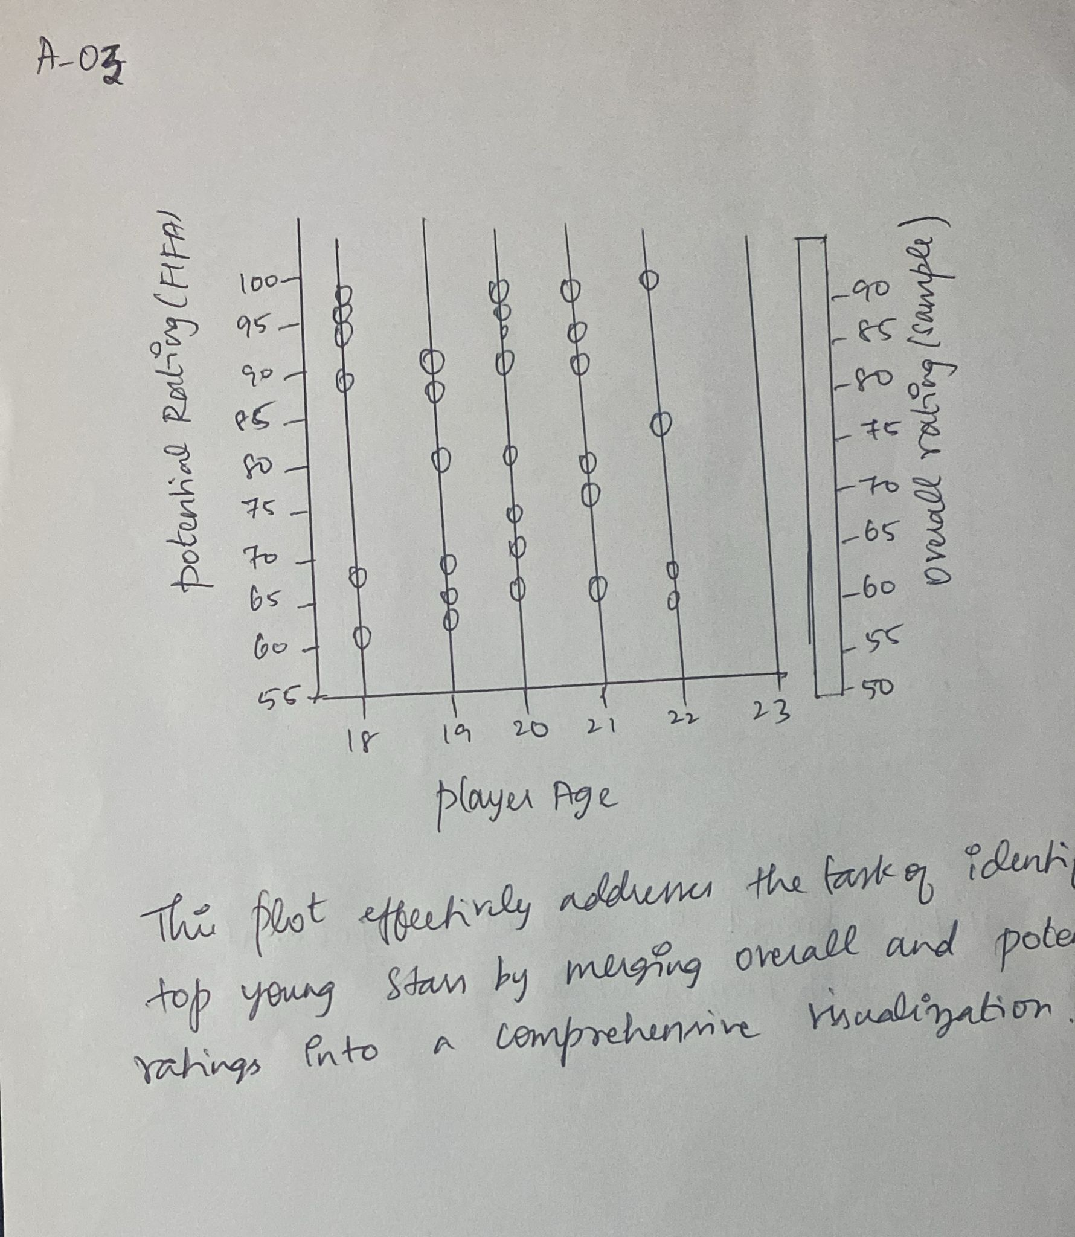
For Task-5:
Combining metrics like goals scored, match wins, and overall league points into a single visualization allows for a powerful way to track a team's performance trajectory over multiple seasons
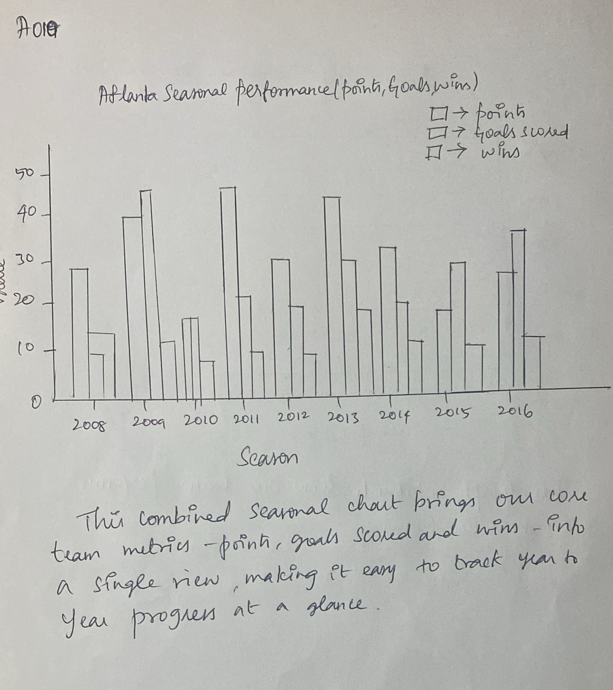

For Task 6:
This bar chart clearly shows team performance against each opponent using bar length to highlight favorable (longer bars, higher win ratios) and unfavorable (shorter bars, lower win/loss ratios)
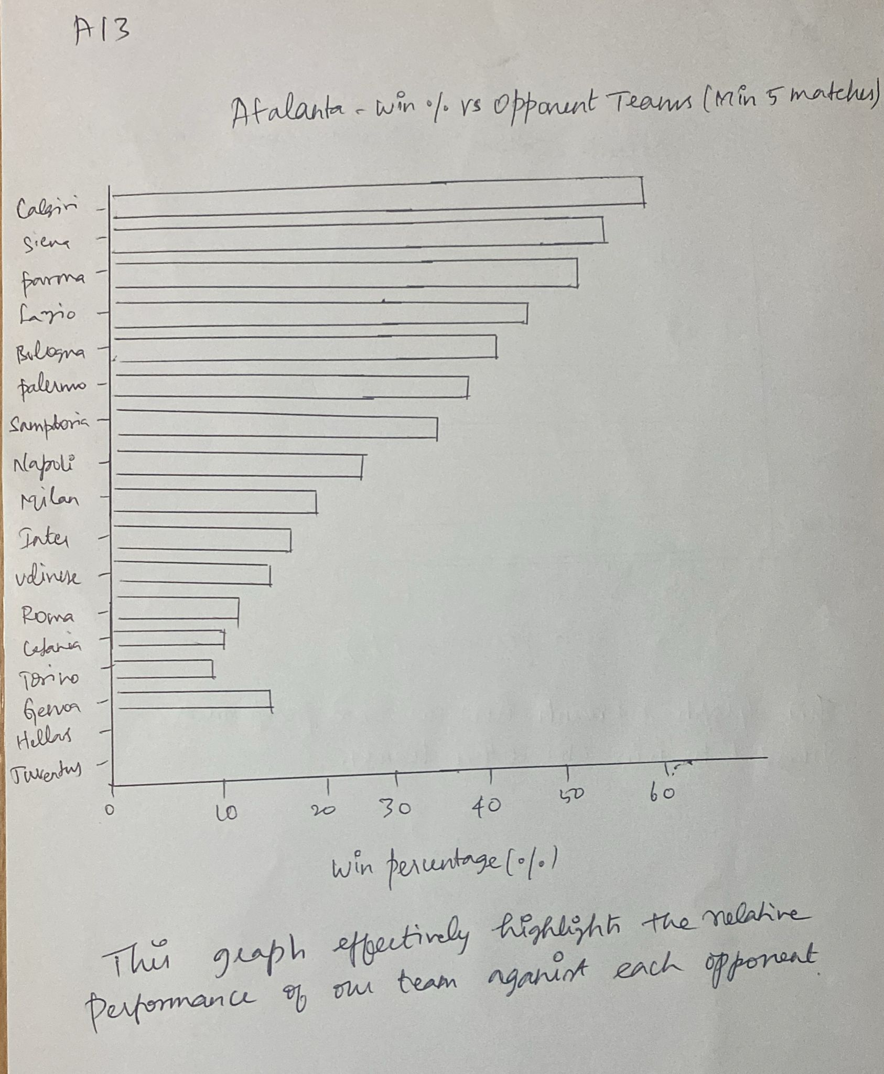
3.3 The final design

In the final design we finalize the best 4 plots and redraw those plots using draw.io.
SKETCH-1:
This plot effectively addresses the task of identifying top young stars by merging overall and potential ratings into a comprehensive visualization. By doing so, it provides a clearer and more effective view of player quality and future promise.
Grouping players by age and position helps to isolate young players across different roles.
Colour and size indicate overall rating, which allows quick visual detection of high-performing or high-potential players.
The highlighted circles (black outline) mark players with potential > 85, making it easy to identify standout talents among youth players.
Overall, the graph is a compact and insightful way to rank and compare young players, making it easier to identify rising stars based on key attributes like age, rating, and potential.
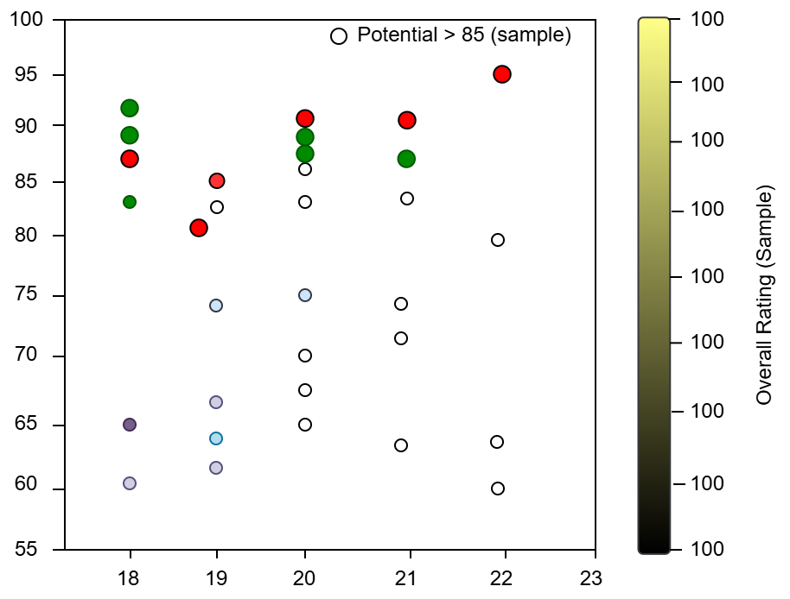

SKETCH-2

The line graph is an effective tool for visualizing team progression over time, aligning well with the task of identifying the most improved teams in recent years.

It tracks total points earned per season for each team, providing a clear visual of performance trends year over year.
The top 5 improving teams are highlighted, making it easy to compare their growth trajectories.Sudden rises or consistent improvements (like Real Madrid CF and SL Benfica) are clearly visible, helping to identify which teams have shown significant progress.The graph also reveals setbacks or inconsistencies, offering a well-rounded view of team development.

Overall, this trend-based visualization gives a comprehensive picture of longitudinal performance, enabling quick and effective comparison of team improvements across seasons.

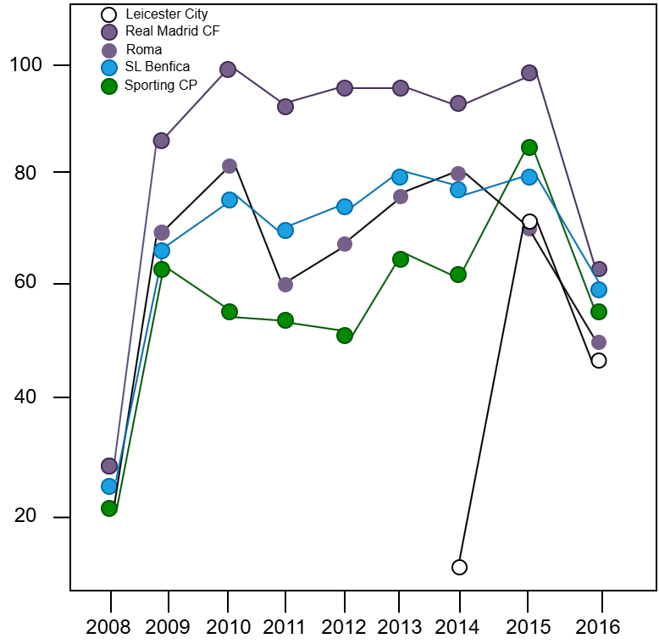

SKETCH-3
This combined seasonal chart brings our core team metrics—points, goals scored and wins—into a single view, making it easy to track year‑to‑year progress at a glance. By overlaying:
Points: You can instantly see overall performance trends (e.g. the jump from 26 in 2011 to 48 in 2012).
Goals Scored: Parallel bars highlight offensive improvements (for instance, goals rising from 23 in 2011 to 35 in 2012).
Wins: Adding win counts shows how scoring and point gains translate into match outcomes (wins doubling from 6 to 14 between 2011–12).
Merging all three measures in one plot lets us compare how offensive output (goals) feeds into results (wins) and league success (points). This integrated visualization makes patterns and turning points immediately visible—ideal for assessing our team’s progression across seasons.
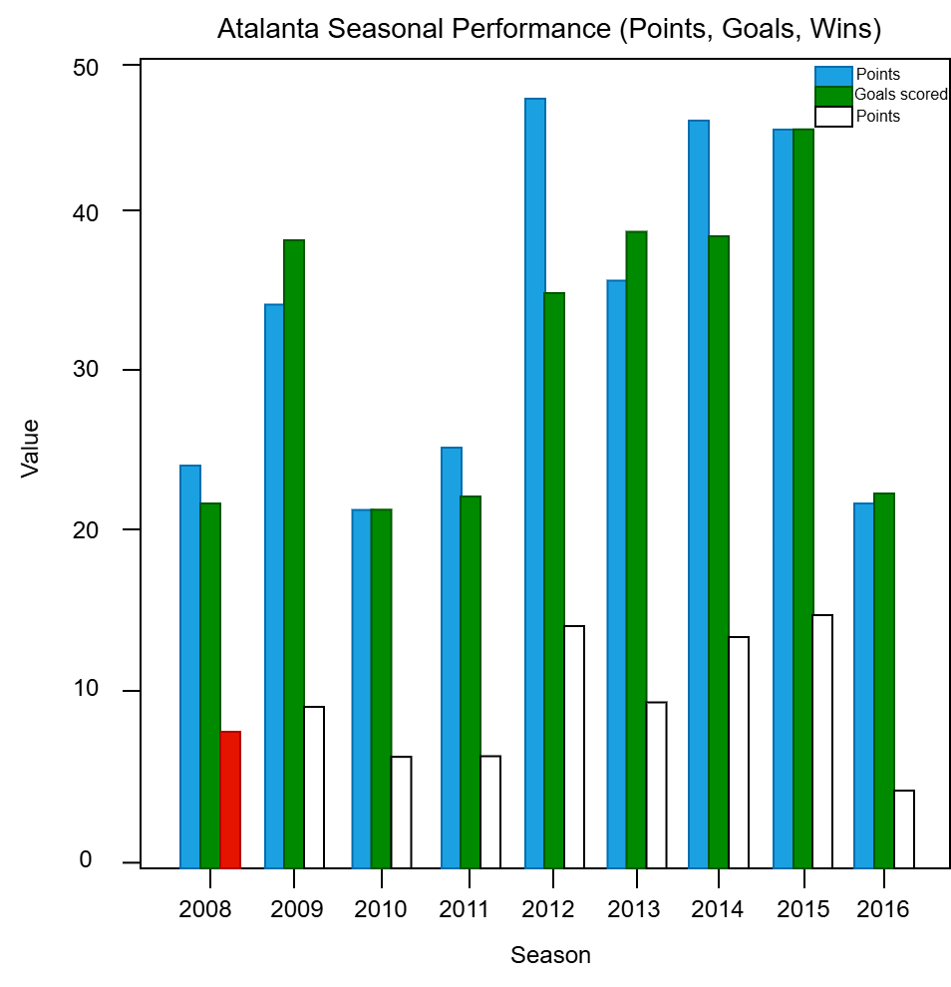

SKETCH-4
This graph effectively highlights the relative performance of your team against each opponent. The length of the bars shows how favorable or unfavorable the outcomes have been:

Longer bars indicate higher win, meaning better performance against those teams.

Shorter bars reflect lower win/loss ratios, showing that the Atlanta team has struggled against.

By grouping the data by opponent and comparing win/loss ratios, this visualization allows for quick identification of best and worst-performing matchups, making it easy to draw actionable insights.
